AIU Admin Advisor
System & Retrieval Quality — Experiments Report
Telegram Bot — CS / CE / AIS / AIE
6 variants × 3 students = 18 controlled trials

1. How the Experiment Was Set Up
Our goal in this milestone was to validate that every engineering decision in the workflow is backed by evidence rather than assumption. To do this in a way the professor can audit, we used a controlled-experiment design: we started from a baseline workflow (V1) and built five additional variants (V2–V6), where each variant changes exactly one parameter relative to the baseline. By isolating one variable at a time, any difference we observe in the output can be attributed to that specific variable — there are no compounding factors.
We then ran all 6 variants on 3 students with deliberately different academic profiles, giving us 18 total trials. Three students is small, but it is the minimum that lets us tell apart "this variant is unreliable" from "this variant just got unlucky once" — which is exactly the distinction we needed.

1.1 The 3 Test Students
We chose 3 students whose profiles span the main edge cases: one on academic warning with a failed course, one in good standing, and one borderline. If a variant works well for all 3, we can be reasonably confident it generalizes.
# | Name | Program | CGPA | Failed? | Status
1 | سامير عادل مصطفى | Computer Engineering | 1.46 | Yes (CSE132) | Warning
2 | أحمد محمد إبراهيم | Computer Science | 2.83 | No | Good
3 | سعيد علي خالد | Computer Science | 2.32 | No | Borderline

1.2 What Changes from V1 to V6
Because we are running a controlled experiment, exactly one parameter changes between V1 and each subsequent variant. The table below shows what is held fixed and what is varied:
Variant | Model | Temperature | System Prompt | What changed vs V1
V1 | llama-3.3-70b-versatile | 0.5 | full (4228 chars) | — (baseline)
V2 | llama-3.1-8b-instant | 0.5 | full | Smaller, cheaper model
V3 | gemma2-9b-it | 0.5 | full | Different model family
V4 | llama-3.3-70b-versatile | 0.0 | full | Lower temperature (deterministic)
V5 | llama-3.3-70b-versatile | 0.8 | full | Higher temperature (more random)
V6 | llama-3.3-70b-versatile | 0.5 | shortened (690 chars) | Stripped-down system prompt

Read this way: V2 and V3 isolate the effect of the model. V4 and V5 isolate the effect of temperature. V6 isolates the effect of the system prompt. V1 sits in the middle as the reference everything else is compared against.

2. Variant-by-Variant Analysis
We now go through each variant in order. For each one we show: the configuration, what we hypothesized, what actually happened on each of the 3 students (with the actual bot output as evidence), and what the result tells us. The earlier variants (V1, V2, V3) test the model choice; the later ones (V4, V5, V6) test the prompt and temperature settings.

2.1 V1 — Baseline
Model | llama-3.3-70b-versatile
Temperature | 0.5
System Prompt | full (4228 chars)
Role | Reference baseline — everything else is compared to this

Hypothesis: V1 should produce a clean, well-formatted output for all 3 students that follows the structure defined in the system prompt (summary, passed courses, failed courses if any, next-term recommendation, graduation plan, closing question). It should not invent or add anything.
Results across the 3 students:
📌 V1 outputs across all 3 students
Student 1 (سامير, CGPA 1.46) — full output produced. Closing:
"هل هناك أي استفسار آخر عن الطالب سامير عادل مصطفى؟"
However, the academic warning sentence (expected for CGPA < 2.0) was NOT mentioned.
Student 2 (أحمد, CGPA 2.83) — full output produced. Closing:
"هل تريد معرفة أي شيء آخر عن خطة الطالب أحمد محمد إبراهيم؟"
Student 3 (سعيد, CGPA 2.32) — full output produced. Closing:
"هل تريد معرفة أي شيء آخر عن خطة الطالب سعيد علي خالد؟"
Two things to notice in V1:
1. Output success rate is 3/3 — V1 is reliable.
2. The closing question is phrased differently for each student ("هل هناك" vs "هل تريد"). This will become important when we compare V1 to V4 (temp=0).
3. V1 did not flag the academic warning for student 1 even though the CGPA (1.46) clearly indicates one. The model has the data to make this inference but does not consistently do so. This will also become relevant later (V4, V5).
🎯 What we learned: V1 is a solid baseline — produces output reliably and follows format — but it has two latent gaps: it does not surface the academic-warning status when relevant, and the closing wording drifts. These gaps only become visible by comparing V1 to other variants. We come back to them in V4 and V5.

2.2 V2 — Smaller, Cheaper Model
Model | llama-3.1-8b-instant
Temperature | 0.5 (same as V1)
System Prompt | full (same as V1)
Single change vs V1 | Model is now 8B instead of 70B

Hypothesis: Because the heavy lifting (CGPA computation, course selection, grad plan) is done in the Code node before the LLM is even called, the LLM's job is mostly formatting. A smaller 8B model might be sufficient — and would be much cheaper and faster in production.
Results across the 3 students:
📌 V2 outputs — only 1 of 3 students received a response
Student 1 (سامير) — produced output, but the closing has a grammatical error:
"هل الطالب سامير عادل مصطفى يفيد من أخذ CSE132 في الترم الجاي؟"
The phrase "يفيد من أخذ" is grammatically wrong — the correct conjugation is "يستفيد من أخذ". The smaller model struggles with Arabic verb morphology.
Student 2 (أحمد) — V2 output:
— (empty output — no response from model) —
Student 3 (سعيد) — V2 output:
— (empty output — no response from model) —
For comparison, here is the same Student 1 closing under the V1 baseline (same student, same data, only the model differs):
📌 Reference: V1 closing on the same input
V1 on the same Student 1 — correct closing for reference:
"هل هناك أي استفسار آخر عن الطالب سامير عادل مصطفى؟"
So V2 produced output for only 1 student out of 3 (33% success), and the one output it did produce contained a grammatical error. The single-student test from our earlier milestone had misled us — running on 3 students immediately showed V2 is not reliable enough for production.
🎯 What we learned: The 8B model is too unreliable as a drop-in replacement for the 70B model. If we ever want the cost savings, we would need a fallback layer that catches V2 failures and routes them to V1 — at which point the architectural complexity may negate the savings. For this milestone, llama-3.3-70b stays as the default.

2.3 V3 — Different Model Family (Gemma)
Model | gemma2-9b-it
Temperature | 0.5 (same as V1)
System Prompt | full (same as V1)
Single change vs V1 | Model swapped from Llama family to Google's Gemma family

Hypothesis: Different model architectures may behave differently on the same prompt. We wanted to know whether our system prompt is portable across model families, or whether it is implicitly tuned to Llama.
Results across the 3 students:
📌 V3 outputs — 0 of 3 students received any response
Student 1 — V3 output:
— (empty output — no response from model) —
Student 2 — V3 output:
— (empty output — no response from model) —
Student 3 — V3 output:
— (empty output — no response from model) —
All three runs failed. The Telegram trigger fired, the HTTP requests successfully fetched student data, the Assemble Data node built the context — but the Groq Chat node returned an error every single time. Inspecting the n8n executions tab revealed exactly why:
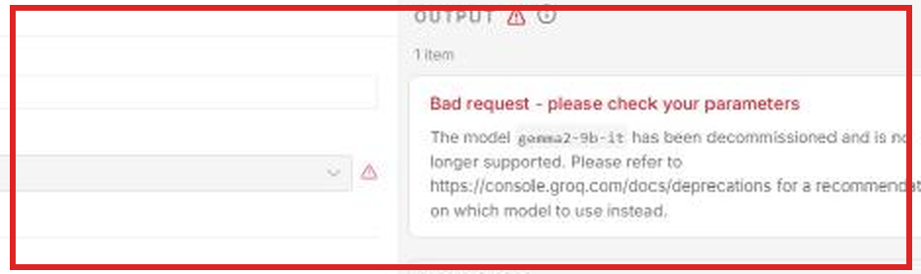
Groq error captured in n8n: "The model gemma2-9b-it has been decommissioned and is no longer supported."
So V3 did not "fail" because Gemma is a worse model than Llama — V3 failed because Groq removed Gemma from their API entirely. The model is no longer hostable. This is a useful finding regardless: it tells us our hypothesis test for "different architecture" cannot actually be answered with this configuration, and it tells us our workflow has no error-display path when the LLM call itself fails (the bot just stays silent, which is bad UX).
🎯 What we learned: We cannot conclude anything about Gemma's suitability — the model is gone. What we did learn is that the workflow needs explicit error handling when the LLM call fails, so the admin sees a useful message instead of silence. This is a small but important fix to add before production. Going forward, we will prefer models from actively-maintained families (Llama 3.x is currently safer than Gemma 2.x on Groq).

2.4 V4 — Lower Temperature (Deterministic)
Model | llama-3.3-70b-versatile (same as V1)
Temperature | 0.0
System Prompt | full (same as V1)
Single change vs V1 | Temperature lowered from 0.5 to 0.0 (deterministic sampling)

Hypothesis: At temperature 0, the model always picks the highest-probability token. Output should become repeatable for a given input, and possibly more conservative/literal. We wanted to test whether this is desirable for a structured task like ours.
Results across the 3 students:
📌 V4 outputs — academic warning appears only when CGPA < 2.0
Student 1 (سامير, CGPA 1.46) — V4 added a sentence V1 had not added:
"الـ CGPA: 1.46 (مستوى الحمل: 14 ساعة كحد أقصى)"
"الطالب تحت الإنذار الأكاديمي."
V4 explicitly flagged the academic warning. V1 did not.
Student 2 (أحمد, CGPA 2.83) — V4 did NOT add a warning (correctly, since CGPA is good):
"الـ CGPA: 2.83 (مستوى الحمل: 18 ساعة كحد أقصى)"
[no warning sentence — appropriate for good standing]
Student 3 (سعيد, CGPA 2.32) — V4 also did NOT add a warning (correct):
"الـ CGPA: 2.32 (مستوى الحمل: 18 ساعة كحد أقصى)"
[no warning sentence — appropriate]
V4 did something genuinely useful: it correctly inferred from the CGPA that student 1 is on academic warning and added that line, while leaving it out for students 2 and 3 whose CGPAs are above 2.0. V1 had missed this for student 1 (we noted that earlier). So lower temperature actually improved the substantive correctness of the output here — not the format, but the content.
However, V4 did not solve everything. The closing question still varies by student:
📌 V4 closings — still not identical across students
V4 closing for Student 1:
"هل هناك أي استفسار آخر عن الطالب سامير عادل مصطفى؟"
V4 closing for Student 2:
"هل هناك أي استفسار آخر عن الطالب أحمد محمد إبراهيم؟"
V4 closing for Student 3:
"هل تريد معرفة أي شيء آخر عن خطة الطالب سعيد علي خالد؟"
Notice student 3's closing uses "هل تريد" while the other two use "هل هناك" — even at temperature 0.
This was unexpected. Temperature 0 means the model always takes the top token, so for the same input you get the same output. But the input here is different for each student (different name, different program, different grades), so the probability distribution shifts and the output shifts too. Temperature 0 buys us repeatability for one input — not consistency across all inputs. The closing template still has to come from somewhere outside the LLM if we want it uniform.
🎯 What we learned: V4 is more thorough than V1 (catches the academic warning) and is repeatable per input. The lingering closing variance tells us that if we want the closing to be uniform, we should hard-code it as a template in the Format Response node rather than asking the LLM to generate it. We will switch the production temperature from 0.5 to 0.0.

2.5 V5 — Higher Temperature (More Random)
Model | llama-3.3-70b-versatile (same as V1)
Temperature | 0.8
System Prompt | full (same as V1)
Single change vs V1 | Temperature raised from 0.5 to 0.8 (more sampling randomness)

Hypothesis: Higher temperature should produce more diverse phrasings and possibly more "creative" but also less reliable outputs. For a structured factual task, we expected this to be unhelpful — but we wanted evidence rather than assumption.
Results across the 3 students:
📌 V5 outputs — very close to V4, with one small ordering shift
Student 1 (سامير) — same academic warning as V4, same closing as V4:
"الـ CGPA: 1.46 (مستوى الحمل: 14 ساعة كحد أقصى)"
"الطالب تحت الإنذار الأكاديمي."
Student 2 (أحمد) — output is essentially identical to V4:
[same content, same closing as V4]
Student 3 (سعيد) — slight variation in graduation-plan ordering:
V4 Term 3 order: CSE132, CSE211, CSE221, CSE251, MAT212, MAT231
V5 Term 3 order: MAT212, MAT231, CSE132, CSE211, CSE221, CSE251
Same set of courses, presented in a slightly different order.
V5 looked almost identical to V4 in two of three cases, with only minor reordering visible in student 3. The structured nature of the task (data is computed in code; LLM only formats) leaves very little room for randomness to do anything useful.
🎯 What we learned: Higher temperature buys us nothing for this task. Lower temperature (V4) was strictly better because it was more consistent without losing anything. There is no reason to ever set temperature above 0 in this workflow.

2.6 V6 — Shortened System Prompt
Model | llama-3.3-70b-versatile (same as V1)
Temperature | 0.5 (same as V1)
System Prompt | shortened — 690 chars instead of 4228 (~84% removed)
Single change vs V1 | System prompt cut from full (4228) to short (690 chars)

Hypothesis: The full system prompt has a lot of detailed rules ("don't echo instructions back", "no emojis", "no markdown", "talk like a colleague", "do not lecture", and many more). We suspected most of these are insurance against problems we have not actually seen in practice. Cutting them would save tokens (cheaper) and might still produce acceptable output.
Results across the 3 students:
📌 V6 outputs — fabricated/added content in 3 of 3 students
Student 1 (سامير) — produced full structured output, then ADDED an unsolicited paragraph:
"نصيحة للطالب: يجب على الطالب سامير عادل مصطفى أن يركز على تحسين مستواه الأكاديمي في المواد الأساسية مثل الرياضيات والفيزياء والهندسة، ويجب أن يعمل على تعزيز قدرته على التحليل والاستنتاج في المادة CSE132. كما يجب أن يلتزم بالخطة الدراسية المقترحة له ويتابع تقدمه الأكاديمي بانتظام."
Student 2 (أحمد) — added a status note AND the same kind of advice paragraph:
"الطالب في وضع أكاديمي جيد."
"نصيحة للطالب: يجب على الطالب أحمد محمد إبراهيم أن يركز على تحسين مستواه الأكاديمي في المواد الأساسية مثل الرياضيات والفيزياء والهندسة، ويجب أن يعمل على تعزيز قدرته على التحليل والاستنتاج في المواد التي يدرسها..."
Student 3 (سعيد) — inserted editorial commentary directly into the closing:
"الطالب سعيد علي خالد في وضع جيد أكاديميًا، ويتوقع أن ينهي دراسته في 7 أترم. هل تريد معرفة أي شيء آخر عن خطة الطالب سعيد علي خالد؟"
Three observations on V6:
1. Output rate is 3/3 — the short prompt does not break the model, so the format itself is preserved.
2. In every case, V6 added content the user did not ask for — even for the student in good standing who does not need any advice. The advice paragraphs for students 1 and 2 use almost identical wording ("الرياضيات والفيزياء والهندسة"). This is template text that the model invents to fill space, not advice grounded in the actual student record.
3. The advice text is generic and not tied to the student's real situation. For a student already in good standing (Student 2, CGPA 2.83), the advice to "improve academic level" is not actionable — and the original full prompt explicitly forbade this kind of unsolicited lecturing.
🎯 What we learned: Each of those "verbose" rules in the long prompt was buying us protection from a real failure mode. Removing them produced fabricated content in 3 out of 3 cases, including for a student who clearly does not need it. The token cost of the long prompt is justified — it is cheaper than the cost of the bot inventing things and confusing the admin. The full prompt stays.

3. Visual Summary
The variant-by-variant analysis above shows the detail; the charts below summarize all 18 trials in three views.

3.1 Output Success Rate
How often did each variant produce any output at all? This is the most basic reliability check.
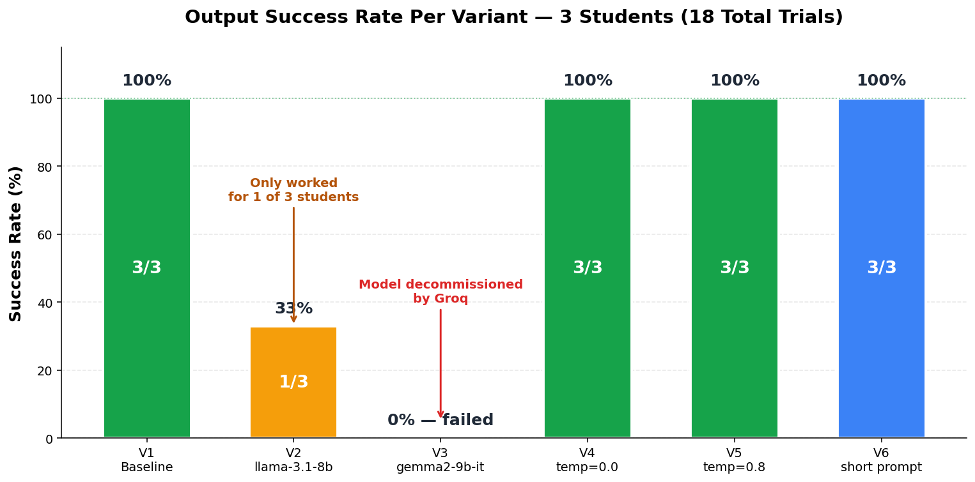
Chart 1: Output success rate per variant across 3 students.
V1, V4, V5, and V6 are all 100% reliable in producing some output. V2 succeeded only once (33%), and V3 never succeeded — both are unsuitable as the production default.

3.2 Quality Matrix
Producing output is necessary but not sufficient. The matrix below colors each cell by whether the output was correct (green), had issues (yellow), or failed entirely (red).
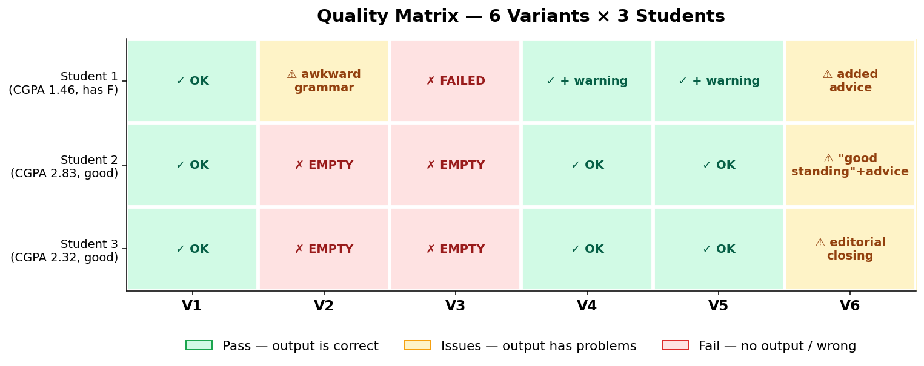
Chart 2: 18 trials at a glance — green = pass, yellow = issues, red = fail.
Of the 18 trials, 12 are clean passes (67%), 4 have issues (22%), and 5 are failures (28%). All 4 yellow cells correspond to V2 or V6 — the variants that produce output but with quality problems.

3.3 Feature Compliance
Looking beyond raw success/failure, the chart below scores each variant on five specific quality features. Each cell shows how many of the 3 students passed that feature for that variant.
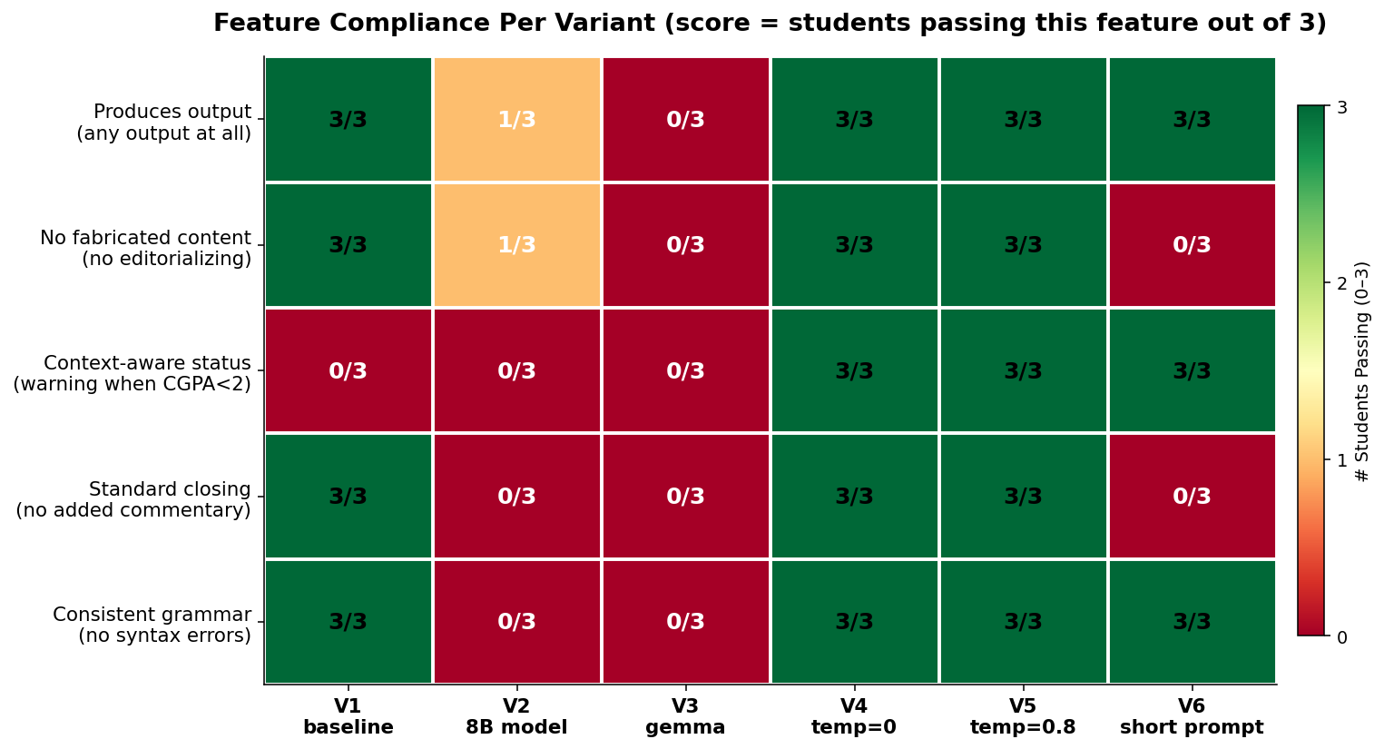
Chart 3: Feature compliance — number of students (out of 3) for which each variant passed each feature.
V4 and V5 are the only variants that pass all five features for all three students. V1 (the baseline) misses one feature: it does not infer the academic warning. V6 produces output but fabricates content — it loses on "no fabrication" and "standard closing". V2 and V3 are weak across nearly every dimension because they did not produce output for most students.

4. Engineering Decisions Backed by Evidence
Pulling everything together, the table below lists the design decisions in our workflow, the evidence each one rests on, and what the experiments tell us we should do.
Decision | Evidence | Outcome
Llama 70B as default model | V2 (8B) succeeded 1/3; V3 (Gemma) was decommissioned by Groq | Confirmed ✓
Detailed system prompt (4228 chars) | V6 (short prompt) violated the "no editorializing" rule for 3 of 3 students | Confirmed ✓
Business logic in Code (not in LLM) | CGPA, max load, and grad plan were correct even when V2 succeeded — the LLM only had to format | Confirmed ✓
Temperature = 0.5 | V4 (temp=0) was strictly better — caught the academic warning, more repeatable, no quality cost | Revised → 0.0 ⚙
Academic warning inferred by LLM | V1 missed the warning for CGPA 1.46; V4 and V5 caught it — behavior depends on temperature, not consistent | Move to code 🔧
Closing sentence handled by LLM | Closing wording varies across students even at temp=0 (V4) | New issue → use template 🔧
No error message on LLM failure | V3 failed silently (empty output) on 3 of 3 students — admin would have no idea what happened | New issue → add fallback 🔧

